BCSE408L Project

5G-Smart Diabetes: Cloud and User Application Development using Machine Learning Algorithms

22BCE0213 | R. Praneeth

Under the Supervision of

Bharathi S
School of Computer Science and Engineering (SCOPE)

B.Tech.
in
Computer Science and Engineering
(with specialization in Core)

School of Computer Science and Engineering

ABSTRACT:
Recent advances in wireless networking and big data technologies, such as 5G networks, medical big data analytics, and the Internet of Things, along with recent developments in wearable computing and artificial intelligence, are enabling the development and implementation of innovative diabetes monitoring systems and applications. Due to the life-long and systematic harm suffered by diabetes patients, it is critical to design effective methods for the diagnosis and treatment of diabetes. Based on our comprehensive investigation, this article classifies those methods into Diabetes 1.0 and Diabetes 2.0, which exhibit deficiencies in terms of networking and intelligence. Thus, our goal is to design a sustainable, cost-effective, and intelligent diabetes diagnosis solution with personalized treatment. In this article, we first propose the 5G-Smart Diabetes system, which combines the state-of-the-art technologies such as wearable 2.0, machine learning, and big data to generate comprehensive sensing and analysis for patients suffering from diabetes. Then we present the data sharing mechanism and personalized data analysis model for 5G-Smart Diabetes. Finally, we build a 5GSmart Diabetes testbed that includes smart clothing, smartphone, and big data clouds. The experimental results show that our system can effectively provide personalized diagnosis and treatment suggestions to patients.

1. INTRODUCTION

Diabetes is an extremely common chronic disease from which nearly 8.5 percent of the world population suffer; 422 million people worldwide have to struggle with diabetes. It is crucial to note that type 2 diabetes mellitus makes up about 90 percent of the cases [1]. More critically, the situation will be worse, as reported in [2], with more teenagers and youth becoming susceptible to diabetes as well. Due to the fact that diabetes has a huge impact on global well-being and economy, it is urgent to improve methods for the prevention and treatment of diabetes [3] Furthermore, various factors can cause the disease, such as improper and unhealthy lifestyle, vulnerable emotion status, along with the accumulated stress from society and work. However, the existing diabetes detection system faces the following problems:
• The system is uncomfortable, and real-time data collection is difficult. Furthermore, it lacks continuous monitoring of multidimensional physiological indicators of patients suffering from diabetes [4, 5].
• The diabetes detection model lacks a data sharing mechanism and personalized analysis of big data from different sources including lifestyle, sports, diet, and so on [6, 7].
• There are no continuous suggestions for the prevention and treatment of diabetes and corresponding supervision strategies [8, 9].

To solve the above problems, in this article, we first propose a next generation diabetes solution called the 5GSmart Diabetes system, which integrates novel technologies including fifth generation (5G) mobile networks, machine learning, medical big data, social networking, smart clothing [10], and so on. Then we present the data sharing mechanism and personalized data analysis model for 5G-Smart Diabetes. Finally, based on the smart clothing, smartphone, and big data healthcare clouds, we build a 5G-Smart Diabetes testbed and give the experiment results.

Furthermore, the “5G” in 5G-Smart Diabetes has a two-fold meaning. On one hand, it refers to the 5G technology that will be adopted as the communication infrastructure to realize high-quality and continuous monitoring of the physiological states of patients with diabetes and to provide treatment services for such patients without restraining their freedom. On the other hand, “5G” refers to the following “5 goals”: cost effectiveness, comfortability, personalization, sustainability, and smartness.

Cost Effectiveness: It is achieved from two aspects. First, 5G-Smart Diabetes keeps users in a healthy lifestyle so as to prevent users from getting the disease in the early stage. The reduction of disease risk would lead to decreasing the cost of diabetes treatment. Second, 5G-Smart Diabetes facilitates out-of-hospital treatment, thus reducing the cost compared to on-the-spot treatment, especially long-term hospitalization of the patient.

Comfortability: To achieve comfort for patients, it is required that 5G-Smart Diabetes does not disturb the patients’ daily activities as much as possible. Thus, 5G-Smart Diabetes integrates smart clothing [3], mobile phones, and portable blood glucose monitoring devices to easily monitor patients’ blood glucose and other physiological indicators.

Personalization: 5G-Smart Diabetes utilizes various machine learning and cognitive computing algorithms to establish personalized diabetes diagnosis for the prevention and treatment of diabetes. Based on the collected blood glucose data and individualized physiological indicators, 5G-Smart Diabetes produces personalized treatment solutions for patients.

Sustainability: By continuously collecting, storing, and analyzing information on personal diabetes, 5G-Smart Diabetes adjusts the treatment strategy in time based on the changes of patients’ status. Furthermore, in order to be sustainable for data-driven diabetes diagnosis and treatment, 5G-Smart Diabetes establishes effective information sharing among patients, relatives, friends, personal health advisors, and doctors.

With the help of social networking, the patient’s mood can be better improved so that he or she is more self-motivated to perform a treatment plan in time. Smartness: With cognitive intelligence toward patients’ status and network resources, 5GSmart Diabetes achieves early detection and prevention of diabetes and provides personalized treatment to patients. The remaining part of the article is organized as follows. We first present the system architecture of 5G-Smart Diabetes. Then we explain the data sharing mechanism and propose the personalized data analysis model. Furthermore, we introduce the 5G-Smart Diabetes testbed.

2. LITERATURE SURVEY

- S. Mendis, “Global Status Report on Noncommunicable Diseases 2014,” WHO, tech. rep.; http://www.who.int/ nmh/publications/ncd-status-report2014/en/, accessed Jan. 2015.
- F. Florencia et al., IDF Diabetes Atlas, 6th ed., Int’l. Diabetes Federation, tech. rep.; http://www.diabetesatlas.org/, accessed Jan. 2016.
- M. Chen et al., “Disease Prediction by Machine Learning over Big Healthcare Data,” IEEE Access, vol. 5, June 2017, pp. 8869--79.
- O. Geman, I. Chiuchisan, and R. Toderean, “Application of Adaptive Neuro-Fuzzy Inference System for Diabetes Classification and prediction},” Proc. 6th IEEE Int’l. Conf. E-Health and Bioengineering, Sinaia, Romania, July 2017, pp. 639--642.
- S. Fong, et al. “Real-Time Decision Rules for Diabetes Therapy Management by Data Stream Mining,” IT Professional, vol. 26, no. 99, June 2017, pp. 1--8.
- B. Lee, J. Kim, “Identification of Type 2 Diabetes Risk Factors Using Phenotypes Consisting of Anthropometry and Triglycerides Based on Machine Learning,” IEEE J. Biomed. Health Info., vol. 20, no. 1, Jan. 2016, pp. 39--46.
- M. Hossain, et al., “Big Data-Driven Service Composition Using Parallel Clustered Particle Swarm Optimization in Mobile Environment,” IEEE Trans. Serv. Comp., vol. 9, no. 5, Aug. 2016, pp. 806--17.
- M. Hossain, “Cloud-Supported Cyber-Physical Localization Framework for Patients Monitoring,” IEEE Sys. J., vol. 11, no. 1, Sept. 2017, pp. 118--27.
- P. Pesl, et al., “An Advanced Bolus Calculator for Type 1 Diabetes: System Architecture and Usability Results,” IEEE J. Biomed. Health Info., vol. 20, no. 1, Jan. 2016, pp. 11-- 17.
- M. Chen et al., “Wearable 2.0: Enable Human-Cloud Integration in Next Generation Healthcare System,” IEEE Commun. Mag., vol. 55, no. 1, Jan. 2017, pp. 54--61.
- E. Marie et al., “Diabetes 2.0: Next-Generation Approach to Diagnosis and Treatment,” Brigham Health Hub, tech. rep.; https://brighamhealthhub.org/diabetes-2-0-nextgeneration-approach- to-diagnosis-and-treatment, 2017, accessed Feb. 2017.
- M. Chen et al., “Green and Mobility-Aware Caching in 5G Networks,” IEEE Trans. Wireless Commun., vol. 16, no. 12, 2017, pp. 8347–61.
- C. Yao et al., “A Convolutional Neural Network Model for Online Medical Guidance,” IEEE Access, vol. 4, Aug. 2016, pp. 4094--4103.
- M. Anthimopoulos et al., “Lung Pattern Classification for Interstitial Lung Diseases Using a Deep Convolutional Neural Network,” IEEE Trans. Med. Imaging, vol. 35, no. 5, May 2016, pp. 1207--16.
- K. Hwang and M. Chen, “Big Data Analytics for Cloud/ IoT and Cognitive Computing,” Wiley, 2017. ISBN: 9781119247029.

2.5 SOFTWARE ENVIRONMENT
Python is a high-level, interpreted scripting language developed in the late 1980s by Guido van Rossum at the National Research Institute for Mathematics and Computer Science in the Netherlands. The initial version was published at the alt. Sources newsgroup in 1991, and version 1.0 was released in 1994.
Python 2.0 was released in 2000, and the 2.x versions were the prevalent releases until December 2008. At that time, the development team made the decision to release version 3.0, which contained a few relatively small but significant changes that were not backward compatible with the 2.x versions. Python 2 and 3 are very similar, and some features of Python 3 have been back ported to Python 2. But in general, they remain not quite compatible.
Both Python 2 and 3 have continued to be maintained and developed, with periodic release updates for both. As of this writing, the most recent versions available are 2.7.15 and 3.6.5. However, an official End of Life date of January 1, 2020 has been established for Python 2, after which time it will no longer be maintained. If you are a newcomer to Python, it is recommended that you focus on Python 3, as this tutorial will do.
Python is still maintained by a core development team at the Institute, and Guido is still in charge, having been given the title of BDFL (Benevolent Dictator For Life) by the Python community. The name Python, by the way, derives not from the snake, but from the British comedy troupe Monty Python’s Flying Circus, of which Guido was, and presumably still is, a fan. It is common to find references to Monty Python sketches and movies scattered throughout the Python documentation.

2.6 WHY CHOOSE PYTHON
If you’re going to write programs, there are literally dozens of commonly used languages to choose from. Why choose Python? Here are some of the features that make Python an appealing choice.

Python is Popular
Python has been growing in popularity over the last few years. The 2018 Stack Overflow Developer Survey ranked Python as the 7th most popular and the number one most wanted technology of the year. World-class software development countries around the globe use Python every single day.
According to research by Dice Python is also one of the hottest skills to have and the most popular programming language in the world based on the Popularity of Programming Language Index.
Due to the popularity and widespread use of Python as a programming language, Python developers are sought after and paid well. If you’d like to dig deeper into Python salary statistics and job opportunities, you can do so here.
Python is interpreted
Many languages are compiled, meaning the source code you create needs to be translated into machine code, the language of your computer’s processor, before it can be run. Programs written in an interpreted language are passed straight to an interpreter that runs them directly.
This makes for a quicker development cycle because you just type in your code and run it, without the intermediate compilation step.
One potential downside to interpreted languages is execution speed. Programs that are compiled into the native language of the computer processor tend to run more quickly than interpreted programs. For some applications that are particularly computationally intensive, like graphics processing or intense number crunching, this can be limiting.
In practice, however, for most programs, the difference in execution speed is measured in milliseconds, or seconds at most, and not appreciably noticeable to a human user. The expediency of coding in an interpreted language is typically worth it for most applications.

Python is Free
The Python interpreter is developed under an OSI-approved open-source license, making it free to install, use, and distribute, even for commercial purposes.
A version of the interpreter is available for virtually any platform there is, including all flavors of Unix, Windows, macOS, smart phones and tablets, and probably anything else you ever heard of. A version even exists for the half dozen people remaining who use OS/2.

Python is Portable
Because Python code is interpreted and not compiled into native machine instructions, code written for one platform will work on any other platform that has the Python interpreter installed. (This is true of any interpreted language, not just Python.)

Python is Simple
As programming languages go, Python is relatively uncluttered, and the developers have deliberately kept it that way.
A rough estimate of the complexity of a language can be gleaned from the number of keywords or reserved words in the language. These are words that are reserved for special meaning by the compiler or interpreter because they designate specific built-in functionality of the language.
Python 3 has 33 keywords, and Python 2 has 31. By contrast, C++ has 62, Java has 53, and Visual Basic has more than 120, though these latter examples probably vary somewhat by implementation or dialect.
Python code has a simple and clean structure that is easy to learn and easy to read. In fact, as you will see, the language definition enforces code structure that is easy to read.
But It’s Not That Simple For all its syntactical simplicity, Python supports most constructs that would be expected in a very high-level language, including complex dynamic data types, structured and functional programming, and object-oriented programming.
Additionally, a very extensive library of classes and functions is available that provides capability well beyond what is built into the language, such as database manipulation or GUI programming.
Python accomplishes what many programming languages don’t: the language itself is simply designed, but it is very versatile in terms of what you can accomplish with it.

Conclusion
This section gave an overview of the Python programming language, including:
- A brief history of the development of Python
- Some reasons why you might select Python as your language of choice
Python is a great option, whether you are a beginning programmer looking to learn the basics, an experienced programmer designing a large application, or anywhere in between. The basics of Python are easily grasped, and yet its capabilities are vast. Proceed to the next section to learn how to acquire and install Python on your computer.
Python is an open source programming language that was made to be easy-to-read and powerful. A Dutch programmer named Guido van Rossum made Python in 1991. He named it after the television show Monty Python's Flying Circus. Many Python examples and tutorials include jokes from the show.
Python is an interpreted language. Interpreted languages do not need to be compiled to run. A program called an interpreter runs Python code on almost any kind of computer. This means that a programmer can change the code and quickly see the results. This also means Python is slower than a compiled language like C, because it is not running machine code directly.
Python is a good programming language for beginners. It is a high-level language, which means a programmer can focus on what to do instead of how to do it. Writing programs in Python takes less time than in some other languages.
Python drew inspiration from other programming languages like C, C++, Java, Perl, and Lisp.
Python has a very easy-to-read syntax. Some of Python's syntax comes from C, because that is the language that Python was written in. But Python uses whitespace to delimit code: spaces or tabs are used to organize code into groups. This is different from C. In C, there is a semicolon at the end of each line and curly braces ({}) are used to group code. Using whitespace to delimit code makes Python a very easy-to-read language.
Python use [change / change source]
Python is used by hundreds of thousands of programmers and is used in many
places. Sometimes only Python code is used for a program, but most of the time it is used to do simple jobs while another programming language is used to do more complicated tasks.
Its standard library is made up of many functions that come with Python when it is installed. On the Internet there are many other libraries available that make it possible for the Python language to do more things. These libraries make it a powerful language; it can do many different things.
Some things that Python is often used for are:
- Web development
- Scientific programming
- Desktop GUIs
- Network programming
- Game programming

3. SYSTEM ANALYSIS
3.1 EXISTING SYSTEM:
The existing systems for diabetes management primarily rely on periodic medical check-ups and self-monitoring techniques, which often result in delayed detection and intervention. Traditional methods include routine visits to healthcare providers for blood glucose testing, HbA1c measurements, and other diagnostics, coupled with patient-maintained logs of daily glucose readings using glucometers. While some advancements have been made with continuous glucose monitors (CGMs) that provide real-time glucose readings, these devices are typically standalone and not integrated with broader health monitoring systems. Additionally, these methods often lack the predictive analytics necessary for proactive disease management and do not facilitate seamless data sharing with healthcare providers. As a result, patients may experience gaps in monitoring and delayed responses to critical health changes, leading to suboptimal disease management and increased healthcare costs.
DISADVANTAGES OF EXISTING SYSTEM:
• Delayed Detection and Intervention: Traditional diabetes management systems rely heavily on periodic medical check-ups and self-monitoring, which can lead to delayed detection of significant changes in a patient's condition. This lag in response can result in severe complications before appropriate medical intervention is initiated.
• Limited Real-Time Monitoring: While continuous glucose monitors (CGMs) provide real-time data, they often function as standalone devices without integration into broader health monitoring ecosystems. This limits their ability to provide comprehensive health insights and coordinated care.
• Lack of Predictive Analytics: Existing systems primarily focus on monitoring current glucose levels without leveraging advanced predictive analytics. This limits their ability to foresee potential health deteriorations and prevents proactive management of the disease.
• Inadequate Data Sharing: Traditional methods lack efficient mechanisms for seamless data sharing between patients and healthcare providers. This results in fragmented health records and insufficient communication, hindering coordinated care and timely medical interventions.
• Patient Burden and Compliance Issues: Self-monitoring techniques, such as daily glucose log maintenance using glucometers, place a significant burden on patients. This can lead to issues with compliance, where patients may forget or fail to consistently monitor their glucose levels, compromising the effectiveness of disease management.

3.2 PROPOSED SYSTEM:
In proposed work, we are using Decision Tree, SVM, Artificial Neural Network algorithms from python to predict patient condition from his data. To train these algorithms we are using diabetes dataset. To predict data efficiently author is using Ensemble Algorithm which is combination of Decision Tree, SVM and ANN algorithm. Training model of all these three algorithms will be merging inside Ensemble Algorithm to get better accuracy and prediction.

ADVANTAGES OF PROPOSED SYSTEM:
- Cost: this technique requires no cost compared to hospitalization as users will be having wearable device which will read his condition and inform to patients and hospitals using his smart phone
- Comfortable: as these wearable devices are small and patients can wear it and keep working on his daily activities.
- Sustainability: Devices can be in contact with hospital servers which will have complex data mining algorithms running on it. After receiving patient data server will run those algorithms to predict patient condition and send report back to devices.
- Personalization: In this technique one patient can share his data with other patient based on distance between cloud servers they are using to store data. Here we are using dataset so sharing is not possible but i am making all predicted test data values to be open so all users can see or share it.
- Smartness: this technique will be consider as smart as its require no human effort to inform patient about current condition.

4. FEASIBILITY STUDY
The feasibility of the project is analyzed in this phase and business proposal is put forth with a very general plan for the project and some cost estimates. During system analysis the feasibility study of the proposed system is to be carried out. This is to ensure that the proposed system is not a burden to the company. For feasibility analysis, some understanding of the major requirements for the system is essential.
Three key considerations involved in the feasibility analysis are
- ECONOMICAL FEASIBILITY
- TECHNICAL FEASIBILITY
- SOCIAL FEASIBILITY

4.1 ECONOMICAL FEASIBILITY
This study is carried out to check the economic impact that the system will have on the organization. The amount of fund that the company can pour into the research and development of the system is limited. The expenditures must be justified. Thus the developed system as well within the budget and this was achieved because most of the technologies used are freely available. Only the customized products had to be purchased.
4.2 TECHNICAL FEASIBILITY
This study is carried out to check the technical feasibility, that is, the technical requirements of the system. Any system developed must not have a high demand on the available technical resources. This will lead to high demands on the available technical resources. This will lead to high demands being placed on the client. The developed system must have a modest requirement, as only minimal or null changes are required for implementing this system.
4.3 SOCIAL FEASIBILITY
The aspect of study is to check the level of acceptance of the system by the user. This includes the process of training the user to use the system efficiently. The user must not feel threatened by the system, instead must accept it as a necessity. The level of acceptance by the users solely depends on the methods that are employed to educate the user about the system and to make him familiar with it. His level of confidence must be raised so that he is also able to make some constructive criticism, which is welcomed, as he is the final user of the system.

5. SYSTEM REQUIREMENTS

5.1 HARDWARE REQUIREMENTS:

- System : Pentium Dual Core.
- Hard Disk : 120 GB.
- Monitor : 15’’ LED
- Input Devices : Keyboard, Mouse
- Ram : 1 GB

5.2 SOFTWARE REQUIREMENTS:

- Operating system : Windows 10
- Coding Language : python (Tkinter)
- Tool : PyCharm
- Database : MYSQL

6. SYSTEM DESIGN

6.1 SYSTEM ARCHITECTURE:

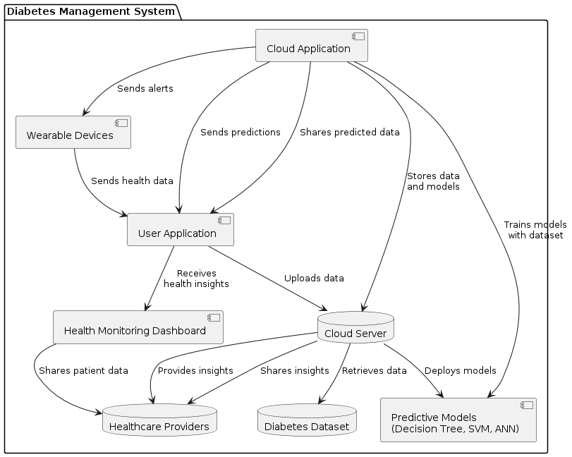

6.2 DATA FLOW DIAGRAM:

- The DFD is also called as bubble chart. It is a simple graphical formalism that can be used to represent a system in terms of input data to the system, various processing carried out on this data, and the output data is generated by this system.
- The data flow diagram (DFD) is one of the most important modeling tools. It is used to model the system components. These components are the system process, the data used by the process, an external entity that interacts with the system and the information flows in the system.
- DFD shows how the information moves through the system and how it is modified by a series of transformations. It is a graphical technique that depicts information flow and the transformations that are applied as data moves from input to output.
- DFD is also known as bubble chart. A DFD may be used to represent a system at any level of abstraction. DFD may be partitioned into levels that represent increasing information flow and functional detail.

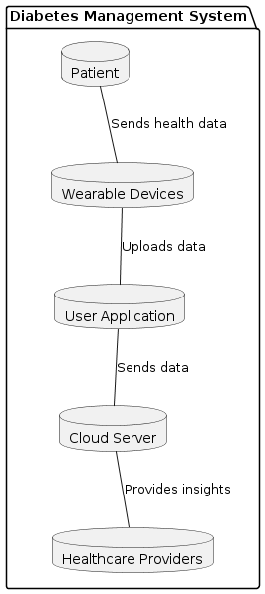

6.3 UML DIAGRAMS:
UML stands for Unified Modeling Language. UML is a standardized general-purpose modeling language in the field of object-oriented software engineering. The standard is managed, and was created by, the Object Management Group.
The goal is for UML to become a common language for creating models of object oriented computer software. In its current form UML is comprised of two major components: a Meta-model and a notation. In the future, some form of method or process may also be added to; or associated with, UML.
The Unified Modeling Language is a standard language for specifying, Visualization, Constructing and documenting the artifacts of software system, as well as for business modeling and other non-software systems.
The UML represents a collection of best engineering practices that have proven successful in the modeling of large and complex systems.
The UML is a very important part of developing objects oriented software and the software development process. The UML uses mostly graphical notations to express the design of software projects.

GOALS:
The Primary goals in the design of the UML are as follows:
- Provide users a ready-to-use, expressive visual modeling Language so that they can develop and exchange meaningful models.
- Provide extendibility and specialization mechanisms to extend the core concepts.
- Be independent of particular programming languages and development process.
- Provide a formal basis for understanding the modeling language.
- Encourage the growth of OO tools market.
- Integrate best practices.

USE CASE DIAGRAM:
A use case diagram in the Unified Modeling Language (UML) is a type of behavioral diagram defined by and created from a Use-case analysis. Its purpose is to present a graphical overview of the functionality provided by a system in terms of actors, their goals (represented as use cases), and any dependencies between those use cases. The main purpose of a use case diagram is to show what system functions are performed for which actor. Roles of the actors in the system can bedepicted.
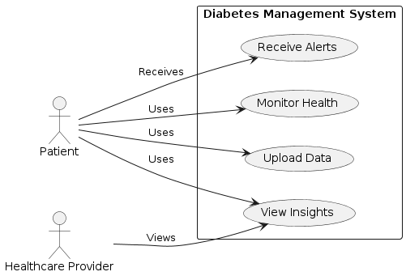
CLASS DIAGRAM:
In software engineering, a class diagram in the Unified Modeling Language (UML) is a type of static structure diagram that describes the structure of a system by showing the system's classes, their attributes, operations (or methods), and the relationships among the classes. It explains which class contains information.

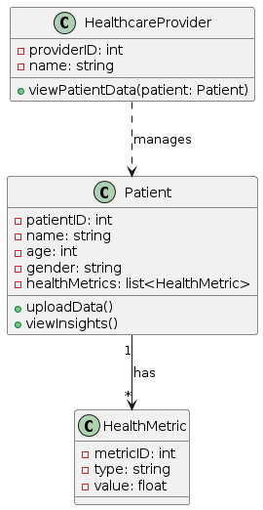

SEQUENCE DIAGRAM:
A sequence diagram in Unified Modeling Language (UML) is a kind of interaction diagram that shows how processes operate with one another and in what order. It is a construct of a Message Sequence Chart. Sequence diagrams are sometimes called event diagrams, event scenarios, and timing diagrams.

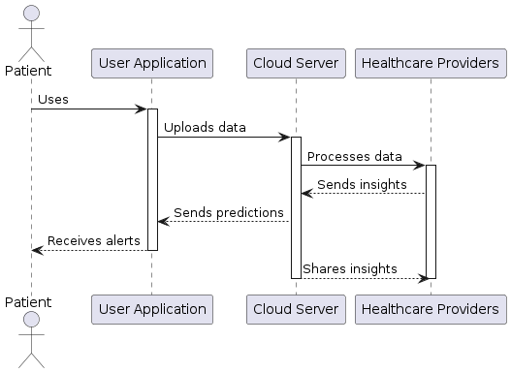

ACTIVITY DIAGRAM:
Activity diagrams are graphical representations of workflows of stepwise activities and actions with support for choice, iteration and concurrency. In the Unified Modeling Language, activity diagrams can be used to describe the business and operational step-by-step workflows of components in a system. An activity diagram shows the overall flow of control.
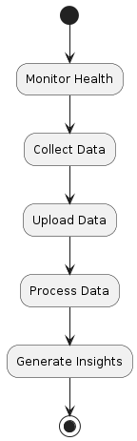

7. IMPLEMENTATION

Implementing a diabetes management system involves several key components and technologies. Here’s a high-level overview of the implementation steps and considerations:

1. **System Architecture Design**
- **Define Components**: Identify and define the core components such as wearable devices, user applications, cloud servers, and healthcare provider interfaces.
- **Choose Technologies**: Select appropriate technologies for data storage (e.g., databases), data processing (e.g., cloud computing), and communication (e.g., APIs, messaging protocols).

2. **Data Collection and Integration**
- **Wearable Devices**: Choose and integrate wearable devices capable of collecting relevant health metrics (e.g., glucose levels, physical activity).
- **Data Integration**: Develop mechanisms for seamless data transmission from wearables to cloud servers, ensuring data security and integrity.

3. **Cloud Infrastructure Setup**
- **Cloud Servers**: Set up cloud infrastructure (e.g., AWS, Azure) for scalable data storage and processing.
- **Database Management**: Implement databases (e.g., SQL, NoSQL) to store patient data and historical records securely.

4. **Data Processing and Analytics**
- **Algorithm Selection**: Choose appropriate machine learning algorithms (e.g., Decision Trees, SVM, ANN) for predictive analytics based on diabetes datasets.
- **Model Training**: Train models using historical data to predict patient conditions and health trends.
- **Real-time Processing**: Implement real-time data processing to provide immediate feedback and alerts to patients and healthcare providers.

5. **User Interface Development**
- **User Applications**: Develop user-friendly applications (web or mobile) for patients to upload data, view insights, and receive alerts.
- **Dashboard for Healthcare Providers**: Create interfaces for healthcare providers to monitor multiple patients, view analytics, and manage alerts.

6. **Integration and Testing**
- **System Integration**: Integrate all components (wearables, cloud services, applications) and ensure seamless communication and functionality.
- **Testing**: Conduct rigorous testing (unit testing, integration testing, performance testing) to validate system functionality, data accuracy, and reliability.

7. **Deployment and Maintenance**
- **Deployment Strategy**: Deploy the system in phases, starting with a pilot group of users before full-scale deployment.
- **Monitoring and Maintenance**: Implement monitoring tools and procedures to ensure system performance, security, and compliance with healthcare regulations.
- **User Support**: Provide ongoing user support and training for patients and healthcare providers to maximize system utilization and effectiveness.

8. **Security and Compliance**
- **Data Security**: Implement robust security measures (encryption, access controls) to protect patient data from unauthorized access or breaches.
- **Compliance**: Ensure compliance with healthcare regulations (e.g., HIPAA in the United States) regarding patient data privacy and security.

9. **Continuous Improvement**
- **Feedback Mechanisms**: Establish feedback mechanisms to gather user feedback and iterate on system features and usability.
- **Updates and Enhancements**: Regularly update the system with new algorithms, features, and improvements based on user feedback and technological advancements.

Example Technologies:
Wearable Devices: Fitbit, Apple Watch, continuous glucose monitors (CGMs).
Cloud Services: AWS (Amazon Web Services), Azure, Google Cloud Platform.
Databases: MySQL, MongoDB, PostgreSQL.
Machine Learning Libraries: TensorFlow, Scikit-learn, PyTorch.
Programming Languages: Python, JavaScript (for web applications), Swift (for iOS apps), Kotlin/Java (for Android apps).

Implementing a diabetes management system requires a multidisciplinary approach, integrating hardware, software, data science, and healthcare expertise to deliver effective and user-centric solutions for managing diabetes and improving patient outcomes.

8. SYSTEM TESTING

The purpose of testing is to discover errors. Testing is the process of trying to discover every conceivable fault or weakness in a work product. It provides a way to check the functionality of components, sub assemblies, assemblies and/or a finished product It is the process of exercising software with the intent of ensuring that the Software system meets its requirements and user expectations and does not fail in an unacceptable manner. There are various types of test. Each test type addresses a specific testing requirement.

TYPES OF TESTS

Unit testing:
Unit testing involves the design of test cases that validate that the internal program logic is functioning properly, and that program inputs produce valid outputs. All decision branches and internal code flow should be validated. It is the testing of individual software units of the application .it is done after the completion of an individual unit before integration. This is a structural testing, that relies on knowledge of its construction and is invasive. Unit tests perform basic tests at component level and test a specific business process, application, and/or system configuration. Unit tests ensure that each unique path of a business process performs accurately to the documented specifications and contains clearly defined inputs and expected results.

Integration testing:
Integration tests are designed to test integrated software components to determine if they actually run as one program. Testing is event driven and is more concerned with the basic outcome of screens or fields. Integration tests demonstrate that although the components were individually satisfaction, as shown by successfully unit testing, the combination of components is correct and consistent. Integration testing is specifically aimed at exposing the problems that arise from the combination of components.

Functional test:
Functional tests provide systematic demonstrations that functions tested are available as specified by the business and technical requirements, system documentation, and user manuals.
Functional testing is centered on the following items:
Valid Input : identified classes of valid input must be accepted.
Invalid Input : identified classes of invalid input must be rejected.
Functions : identified functions must be exercised.
Output : identified classes of application outputs must be exercised.
Systems/Procedures : interfacing systems or procedures must be invoked.
Organization and preparation of functional tests is focused on requirements, key functions, or special test cases. In addition, systematic coverage pertaining to identify Business process flows; data fields, predefined processes, and successive processes must be considered for testing. Before functional testing is complete, additional tests are identified and the effective value of current tests is determined.

System Test:
System testing ensures that the entire integrated software system meets requirements. It tests a configuration to ensure known and predictable results. An example of system testing is the configuration oriented system integration test. System testing is based on process descriptions and flows, emphasizing pre-driven process links and integration points.

White Box Testing:
White Box Testing is a testing in which in which the software tester has knowledge of the inner workings, structure and language of the software, or at least its purpose. It is purpose. It is used to test areas that cannot be reached from a black box level.

Black Box Testing:
Black Box Testing is testing the software without any knowledge of the inner workings, structure or language of the module being tested. Black box tests, as most other kinds of tests, must be written from a definitive source document, such as specification or requirements document, such as specification or requirements document. It is a testing in which the software under test is treated, as a black box .you cannot “see” into it. The test provides inputs and responds to outputs without considering how the software works.
8.1 Unit Testing:
Unit testing is usually conducted as part of a combined code and unit test phase of the software lifecycle, although it is not uncommon for coding and unit testing to be conducted as two distinct phases.

Test strategy and approach:
Field testing will be performed manually and functional tests will be written in detail.

Test objectives:
- All field entries must work properly.
- Pages must be activated from the identified link.
- The entry screen, messages and responses must not be delayed.

Features to be tested
- Verify that the entries are of the correct format
- No duplicate entries should be allowed
- All links should take the user to the correct page.

8.2 Integration Testing
Software integration testing is the incremental integration testing of two or more integrated software components on a single platform to produce failures caused by interface defects.
The task of the integration test is to check that components or software applications, e.g. components in a software system or – one step up – software applications at the company level – interact without error.
Test Results: All the test cases mentioned above passed successfully. No defects encountered.

8.3 Acceptance Testing
User Acceptance Testing is a critical phase of any project and requires significant participation by the end user. It also ensures that the system meets the functional requirements.
Test Results: All the test cases mentioned above passed successfully. No defects encountered.

9. INPUT DESIGN AND OUTPUT DESIGN
9.1 INPUT DESIGN:
The input design is the link between the information system and the user. It comprises the developing specification and procedures for data preparation and those steps are necessary to put transaction data in to a usable form for processingcan be achieved by inspecting the computer to read data from a written or printed document or it can occur by having people keying the data directly into the system. The design of input focuses on controlling the amount of input required, controlling the errors, avoiding delay, avoiding extra steps and keeping the process simple. The input is designed in such a way so that it provides security and ease of use with retaining the privacy. Input Design considered the following things:
- What data should be given as input?
- How the data should be arranged or coded?
- The dialog to guide the operating personnel in providing input.
- Methods for preparing input validations and steps to follow when error occur.
OBJECTIVES:
1. Input Design is the process of converting a user-oriented description of the input into a computer-based system. This design is important to avoid errors in the data input process and show the correct direction to the management for getting correct information from the computerized system.
2.It is achieved by creating user-friendly screens for the data entry to handle large volume of data. The goal of designing input is to make data entry easier and to be free from errors. The data entry screen is designed in such a way that all the data manipulates can be performed. It also provides record viewing facilities.
3. When the data is entered it will check for its validity. Data can be entered with the help of screens. Appropriate messages are provided as when needed so that the user will not be in maize of instant. Thus the objective of input design is to create an input layout that is easy to follow
9.2 OUTPUT DESIGN:
A quality output is one, which meets the requirements of the end user and presents the information clearly. In any system results of processing are communicated to the users and to other system through outputs. In output design it is determined how the information is to be displaced for immediate need and also the hard copy output. It is the most important and direct source information to the user. Efficient and intelligent output design improves the system’s relationship to help user decision-making.
1. Designing computer output should proceed in an organized, well thought out manner; the right output must be developed while ensuring that each output element is designed so that people will find the system can use easily and effectively. When analysis design computer output, they should Identify the specific output that is needed to meet the requirements.
2. Select methods for presenting information.
3. Create document, report, or other formats that contain information produced by the system.
The output form of an information system should accomplish one or more of the following objectives.
- Convey information about past activities, current status or projections of the
- Future.
- Signal important events, opportunities, problems, or warnings.
- Trigger an action.
- Confirm an action.
10. SCREENSHOTS
Double click on ‘run.bat’ file from ‘Cloud’ folder to start cloud server and to get below screen
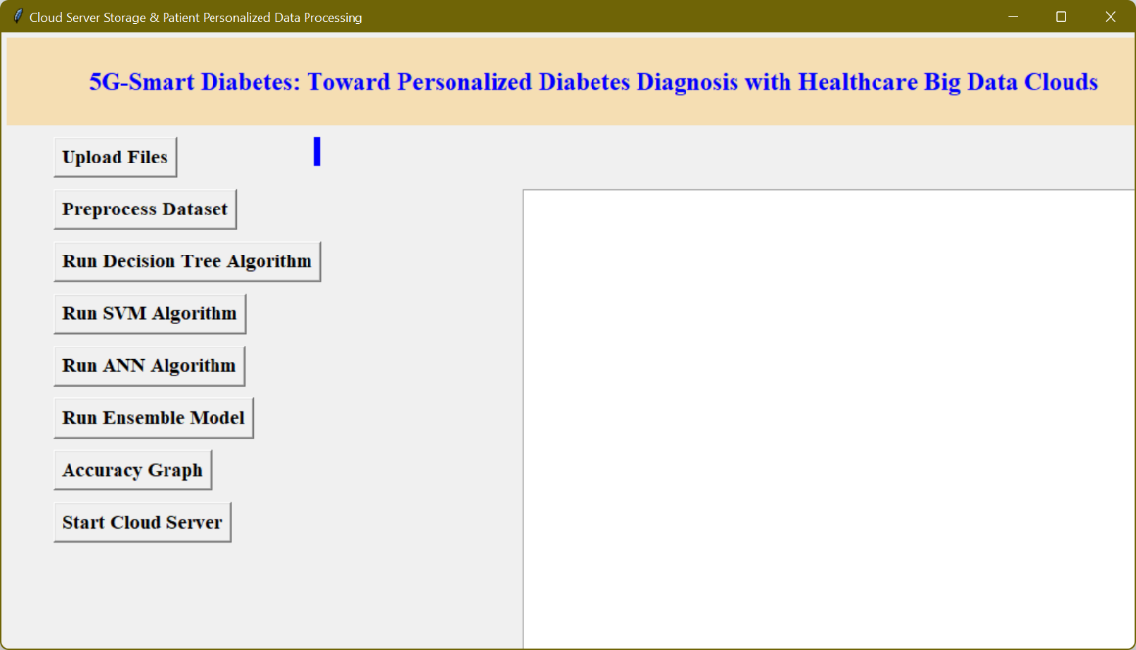
In above screen click on ‘Upload Files’ button to upload diabetes dataset
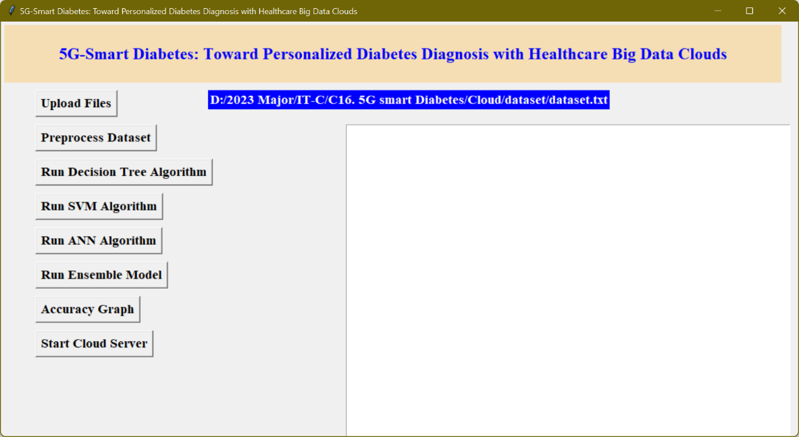
After uploading dataset click on ‘Pre-process Dataset’ button to clean dataset
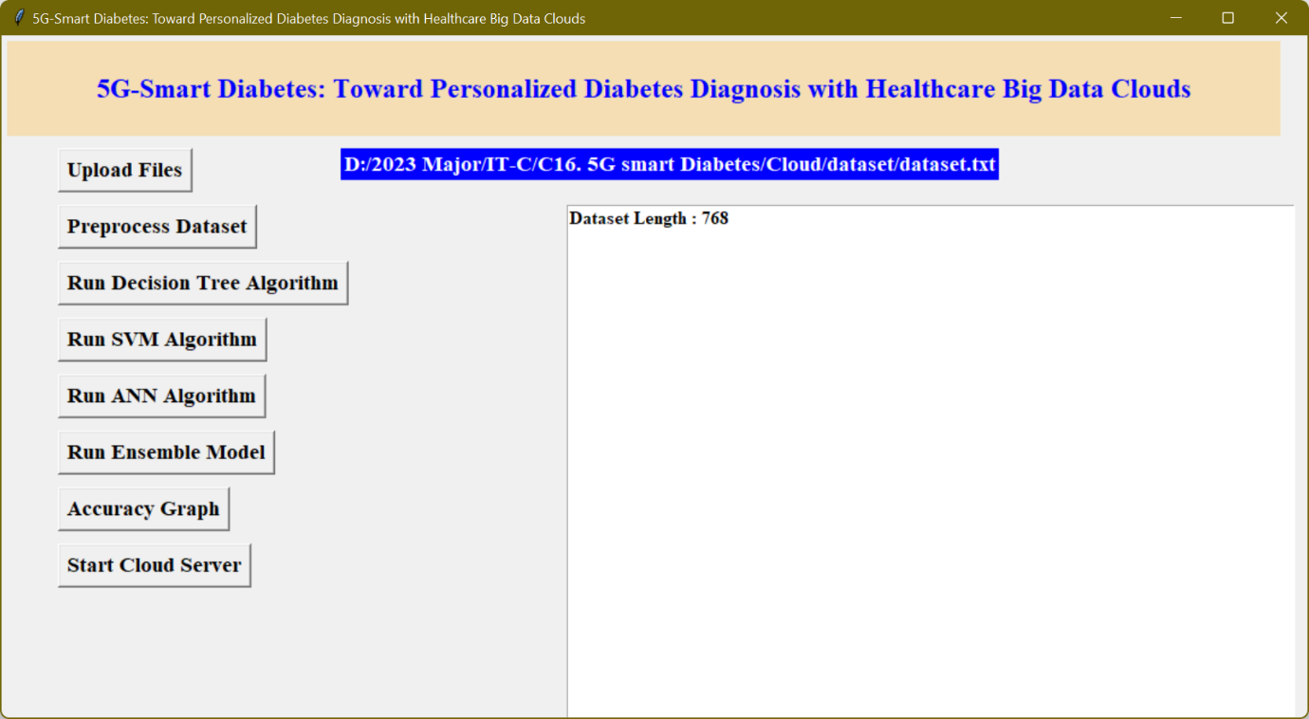
In above screen after pre-process total dataset records are 768. Now click on ‘Run Decision Tree Algorithm’ to build decision tree model and below is its accuracy
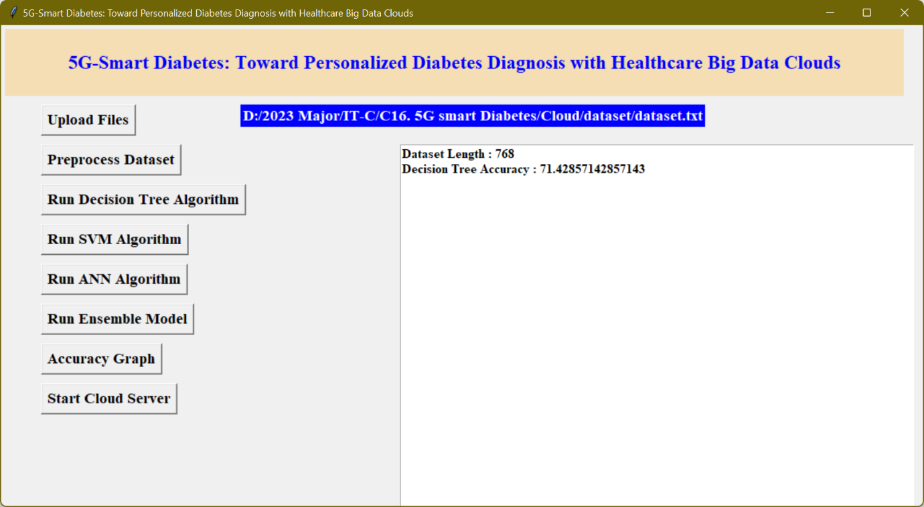
Similarly run other buttons to build models with algorithms
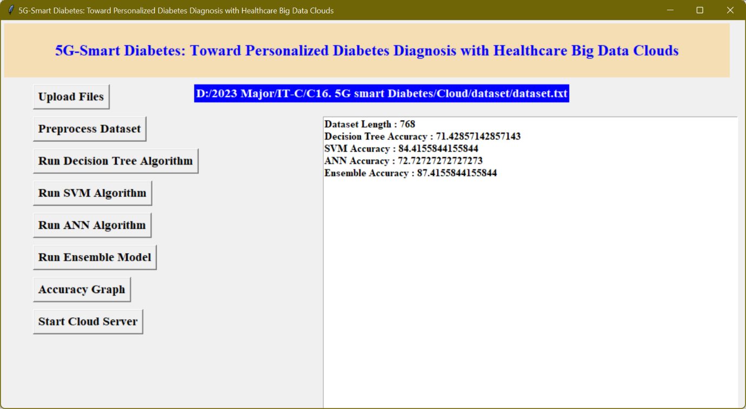
In above screen we got accuracy for all algorithms, now click on ‘Accuracy Graph’ button to get accuracy of all algorithms
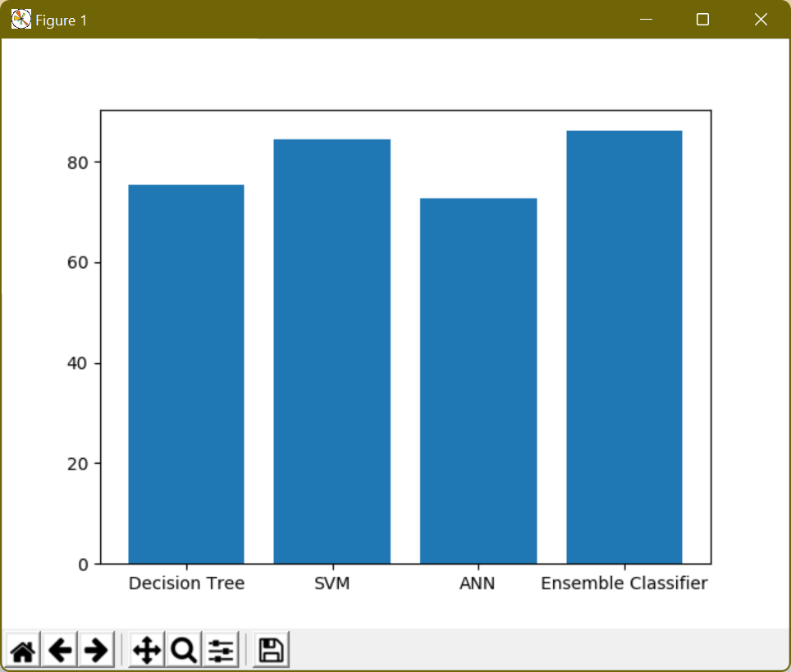
In above screen graph x-axis represents algorithm name and y-axis represents accuracy values.

Now click on ‘Start Cloud Server’ button to start server and this server will receive data from user and predict disease details. and now double clicks on ‘run.bat’ file from User folder to start User sensing application and click on ‘Upload Files’ button to upload test file and to predict patient condition. After uploading users’ data will get below prediction results
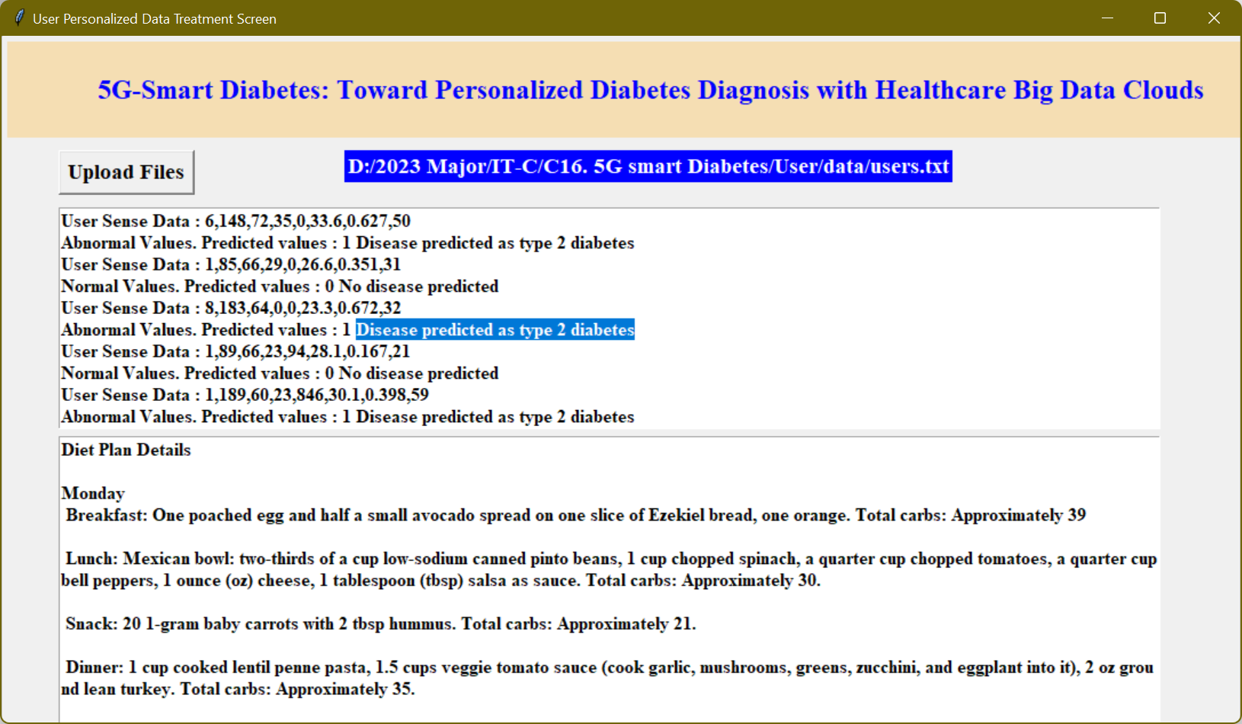
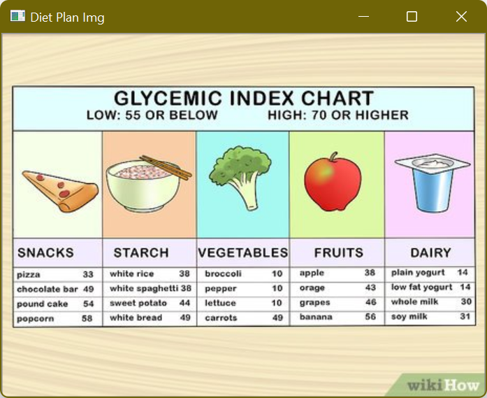
In above screen for each user data, we predicted 0 and 1 values and also indicates patient values as normal or abnormal. Further, it also suggests the diet plan.

11. FUTURE ENHANCEMENT
Future enhancements for the diabetes management system could focus on several key areas to further improve its effectiveness, user experience, and scalability. One major enhancement would involve integrating more advanced artificial intelligence (AI) and machine learning (ML) algorithms, such as deep learning models, to increase the accuracy and reliability of health predictions and personalized treatment recommendations. Incorporating natural language processing (NLP) capabilities could enable the system to analyze patient feedback and medical records more effectively, providing deeper insights into individual patient needs and improving the personalization of care.

Additionally, expanding the range of health metrics monitored by wearable devices to include blood pressure, heart rate variability, and other vital signs could provide a more comprehensive view of a patient's health, allowing for better management of comorbid conditions. Enhanced interoperability with other healthcare systems and electronic health records (EHR) would facilitate seamless data sharing and coordination among different healthcare providers, leading to more integrated and efficient patient care.

Future versions of the system could also incorporate blockchain technology to ensure the security and integrity of patient data, enhancing trust among users. Further development of user interfaces, such as voice-activated assistants and augmented reality (AR) applications, could improve accessibility and usability, especially for elderly patients or those with disabilities. Finally, expanding the system's reach through global partnerships and multilingual support could make it accessible to a broader audience, addressing diabetes management needs in diverse populations worldwide. These enhancements would collectively contribute to a more robust, user-friendly, and effective diabetes management system, ultimately leading to better health outcomes for patients.

12. CONCLUSION

In conclusion, the proposed diabetes management system leveraging 5G technology, wearable devices, and advanced machine learning algorithms offers a transformative approach to managing diabetes. By providing real-time monitoring, predictive analytics, and seamless data integration, this system addresses many of the limitations of traditional diabetes care, such as delayed intervention and high healthcare costs. The system enhances patient comfort and convenience through continuous, non-invasive monitoring and empowers healthcare providers with timely, accurate insights for proactive care. Future enhancements, including the integration of advanced AI, expanded health metrics, and improved interoperability, hold the potential to further refine and expand the system's capabilities. Overall, this innovative approach represents a significant advancement in diabetes management, promising improved health outcomes and quality of life for patients while reducing the burden on healthcare systems.

13. BIBLIOGRAPHY
1. S. Mendis, “Global Status Report on Noncommunicable Diseases 2014,” WHO, tech. rep.; http://www.who.int/ nmh/publications/ncd-status-report-2014/en/, accessed Jan. 2015.

2. F. Florencia et al.,IDF Diabetes Atlas, 6th ed., Int’l. Diabetes Federation, tech. rep.; http://www.diabetesatlas.org/, accessed Jan. 2016.

3. M. Chen et al., “Disease Prediction by Machine Learning over Big Healthcare Data,” IEEE Access, vol. 5, June 2017, pp. 8869--79.

4. O. Geman, I. Chiuchisan, and R. Toderean, “Application of Adaptive Neuro-Fuzzy Inference System for Diabetes Classification and prediction},” Proc. 6th IEEE Int’l. Conf. EHealth and Bioengineering, Sinaia, Romania, July 2017, pp. 639-- 642.

5. S. Fong, et al. “Real-Time Decision Rules for Diabetes Therapy Management by Data Stream Mining,” IT Professional, vol. 26, no. 99, June 2017, pp. 1--8.

6. B. Lee, J. Kim, “Identification of Type 2 Diabetes Risk Factors Using Phenotypes Consisting of Anthropometry and Triglycerides Based on Machine Learning,” IEEE J. Biomed. Health Info., vol. 20, no. 1, Jan. 2016, pp. 39--46

7. M. Hossain, et al., “Big Data-Driven Service Composition Using Parallel Clustered Particle Swarm Optimization in Mobile Environment,” IEEE Trans. Serv. Comp., vol. 9, no. 5, Aug. 2016, pp. 806--17.

8. M. Hossain, “Cloud-Supported Cyber-Physical Localization Framework for Patients Monitoring,” IEEE Sys. J., vol. 11, no. 1, Sept. 2017, pp. 118--27.

9. P. Pesl, et al., “An Advanced Bolus Calculator for Type 1 Diabetes: System Architecture and Usability Results,” IEEE J. Biomed. Health Info., vol. 20, no. 1, Jan. 2016, pp. 11--17.

10. M. Chen et al., “Wearable 2.0: Enable Human-Cloud Integration in Next Generation Healthcare System,” IEEE Commun. Mag., vol. 55, no. 1, Jan. 2017, pp. 54--61.

11. E. Marie et al., “Diabetes 2.0: Next-Generation Approach to Diagnosis and Treatment,” Brigham Health Hub, tech. rep.; https://brighamhealthhub.org/diabetes-2-0-next-generationapproach- to-diagnosis-and-treatment, 2017, accessed Feb. 2017.

12. M. Chen et al., “Green and Mobility-Aware Caching in 5G Networks,” IEEE Trans. Wireless Commun., vol. 16, no. 12, 2017, pp. 8347–61.

13. C. Yao et al., “A Convolutional Neural Network Model for Online Medical Guidance,” IEEE Access, vol. 4, Aug. 2016, pp. 4094--4103.

14. M. Anthimopoulos et al., “Lung Pattern Classification for Interstitial Lung Diseases Using a Deep Convolutional Neural Network,” IEEE Trans. Med. Imaging, vol. 35, no. 5, May 2016, pp. 1207--16.

15. K. Hwang and M. Chen, “Big Data Analytics for Cloud/ IoT and Cognitive Computing,” Wiley, 2017. ISBN: 9781119247029.

